Did the Egyptians Use the Sun to Align the Pyramids?

By Glen Dash, Glen Dash Foundation for Archaeological Research

The Egyptians aligned pyramids of the fourth dynasty, including the Great Pyramid of Khufu and its neighbor, Khafre, to cardinal points with amazing accuracy. The casing of the Great Pyramid was aligned to true north to within four minutes of arc, better than one fifteenth of one degree. For the most part, scholars who have studied the issue have concluded that the Egyptians must have used the nighttime stars to achieve such accuracy. Wrote one, “[I]t is nearly impossible to attain such a high precision using solar methods”.

Martin Isler, an American illustrator and sculptor, disagreed. Though not formally trained as an archaeologist, Isler had earned professional recognition for his studies on the methods the Egyptians had used to work and move stone. On the issue of pyramid alignments, Isler argued that the Egyptians could have used a technique known as the “Indian Circle Method,” thought to have been pioneered on the Indian subcontinent.

In this article, I put the Indian Circle method to the test. I find that, with one critical modification, the method works, and is capable of yielding results sufficiently accurate to account for the alignment of the pyramids’ casings.

The Indian Circle method is illustrated in Figure 1. An observer starts by setting a rod vertically in the ground. The rod is known as a gnomon, Greek for “one who knows.” As the day passes, the shadow produced by the gnomon is tracked by the observer, who marks its position on the ground every few minutes, eventually producing a curve called the shadow line. At the end of the day, the observer fixes a string to the rod and draws a circle which intersects the shadow line at two points. In theory, a line drawn through those two points will run exactly east-west.

I tested the Indian Circle method at my home in Pomfret, Connecticut in mid-summer near the solstice when the sun was highest in the sky and shadows sharp. Because the ground around my house was uneven, I built a raised wooden platform and leveled it. (Figure 2) I set the gnomon along the platform’s midline, and, because it would throw its shadow to the north, attached it to the platform’s south side. The gnomon stood 6 feet 11 inches feet (2.111m) above the platform’s surface and included a 1.25 inch (3.18cm) diameter dowel attached to its north side which, for the reasons discussed below, was cantilevered over the platform (Figure 3). I threaded a 0.25 inch (6.4mm) steel pin into the top of the dowel. In my tests, I tracked the movement of the sun by observing the shadow cast by the rounded tip of the dowel rod. I used the metal pin to anchor the string used to draw the circle around the gnomon.

For convenience, I wanted to start the test around eight in the morning. At that time, near the solstice, the sun is almost due east. Therefore, in order to get the gnomon’s shadow to fall on the platform, I had to cantilever its tip, moving its position slightly south of the platform’s northern edge. I also knew that leveling was important. I leveled the platform as best I could using a spirit level, but because plywood warps, I was never able to achieve a level of better than 0.25 inches (6.4mm) over its 20 foot, 3 inch (6.2m) length, making the platform as much as .06 degree out of level. The Egyptians, working in stone, were much better at this than I was. They leveled the entire base of the Great Pyramid to within 2.5 centimeters over it entire 920 meter periphery, for and a leveling error of less than .002 degree. Fortunately, my leveling efforts proved good enough. The Egyptians, in all likelihood, working in stone could have done it better.

Figure 3 shows the shadow produced by the gnomon. I found that it took two people to efficiently record the shadow’s position. In Figure 4, Dr. Joan Dash marks the location of the shadow while I view it from about one meter away. The two of us would agree on a location every minute or so, when Joan would mark the agreed location on the quarter inch (6.4 mm) ruled graph paper. We could time a minute interval simply by watching the shadow’s movement. We found that we only needed to take data for about an hour in the morning and an hour in the afternoon to complete the test. Figure 5 shows a typical set of results.

In the Indian Circle method, the next step is to attach a string to the base of the gnomon and use it to draw an intersecting circle with the shadow line. For the method to work well, however, the circle must be precisely centered on the part of the gnomon which produced the shadow. If I drew the circle from the base of the rod, as Isler had proposed, the gnomon would have to be set perfectly straight and vertical, something which is difficult to do using only the tools the Egyptians had. Therefore, I modified the technique by drawing the string from the top of the gnomon instead of the bottom. (Figure 6) I threaded the string over the metal pin I inserted at the top of the dowel rod, and drew it out to a point on the afternoon data. I chose a point on the afternoon data’s where the shadow line ran smooth. I marked the exact point where the string touched the shadow line on the string. I then pulled the string over to the morning’s data and marked the location where the point I marked on the string matched the morning’s data. I repeated the process four times and circled the four sets of intersecting points.

Prior to the test, I had set up a survey grid precisely aligned with true north using a total station. Now, using the total station, I measured the four sets of points and determined the true angle of the lines running through them (Figure 7). Table 1 shows the results:

Table 1: Error off True East-West Produced by the Indian Circle Method

Intersecting Pair | Clockwise Angle off Due East-West
1 | -3 minutes, 26 seconds (-.057 degrees)
2 | -4 minutes, 34 seconds (-.076 degrees)
3 | -1 minute, 26 seconds (-.024 degrees)
4 | +50 seconds (.014 degrees)
Average | -2 minutes, 9 seconds (-.036 degrees)

The average error was 2 minutes and 9 seconds, about 1/28 of a degree, better than the 3 minute 38 second alignment of the Great Pyramid’s casing. Three of the four lines ran just north of east, exhibiting a counterclockwise rotation from straight east-west (a clockwise rotation is denoted by a positive sign in the table). Data taken later in the morning and earlier in the afternoon were more accurate, probably because the sun was higher in the sky and the shadows sharper.

While this method might have sufficed, it does take some practice to reliably identify where the shadow falls. To make things easier, I tried using an angled block of wood as a “shadow definer” (Figure 8). The block, covered in white paper, was angled at 50 degrees so it would be more or less perpendicular to the rays of the sun during the test. While the angled block did make the shadow’s tip easier to see, it produced its own set of errors which became greater later in the morning and earlier in the afternoon (Table 2).

Table 2: Error off True East-West Produced by the Indian Circle Method Using an Angled Block as a Shadow Definer

Intersecting Pair | Clockwise Angle off Due East-West
1 | No measureable error
2 | -3 minutes, 17 seconds (-.055 degrees)
3 | -4 minute, 58 seconds (-.083 degrees)
4 | -6 minutes, 54 seconds (-.115 degrees)
Average | -3 minutes, 47 seconds (-.063 degrees)

Other cultures also used solar gnomons to perform such tasks as tracking the time of the day or the passing of the seasons. Some used sophisticated shadow definers. To test the limits of the Indian Circle method, I used one described in the Yuan Shih, a history of Yuan Dynasty. It consists of a copper leaf with a pin hole in its center. The pin hole acts as a lens, focusing the image of the gnomon. I made the shadow definer by drilling a 1/16” (1.6mm) hole in a 6.75 x 5 inch (17.1 x 12.7cm) sheet of copper, which I angled at 50 degrees to best catch the rays of the sun. I mounted it on a 19 inch (48.3cm) high wooden frame (Figure 9). The shadow definer produced a well focused image of the gnomon’s tip, so well focused, in fact, that I could clearly see the quarter inch diameter rod rising above the wooden dowel. I decided to track the sun by aligning the tip of the metal pin with the top of the image of the sun, and marked that location on the paper every minute or so. The results were impressive (Table 3). The average error was just 19 seconds or arc or about 1/180th of a degree, close to what I could expect to achieve with a total station.

Table 3: Error off True East-West Lines Produced by the Indian Circle Method Using a Pin Hole as a Shadow Definer

Intersecting Pair | Clockwise Angle off Due East-West
1 | No measureable error
2 | 36 seconds (.010 degrees)
3 | No measureable error
4 | 39 seconds (.011 degrees)
Average | 19 seconds (.005 degrees)

My tests showed that the Egyptians could have aligned the casing of the Great Pyramid to cardinal points using the Indian Circle method. The method is best performed near the summer solstice when the sun is high in the sky and shadows sharp. It requires an observer to track the motion of the sun for an hour or so in the morning and again in the afternoon. Using a string attached to the tip of the gnomon, the observer then draws a circle, identifying two points of intersection which will run east-west. While workable, the method requires a keen eye, and the Egyptians may have found that a “shadow definer,” such as an angled block of wood, helps. On the other hand, had the Egyptians used the pin hole shadow definer described by the Yuan Dynasty Chinese, their results might have been even better.

The Egyptians of the Old Kingdom left us no pictorial or written records which cast any light on the methods they employed to align their great monuments. Therefore, I cannot say with any certainty that the Egyptians actually used the sun to align the casing of their pyramids with cardinal points. However, I can definitely say that they could have done so, and needed only the tools they had at hand -- wood, rope, copper and stone.
References

Arnold, Dieter, Building in Egypt, New York: Oxford University Press, 1991

Dash, Glen, “North by Northwest: The Strange Case of Giza’s Misalignments,” AERAGRAM, Vol. 13 no. 1 (Spring 2012), 10-15

Dash, Glen, “New Angles on the Great Pyramid,” AERAGRAM, Vol. 13 no. 2 (Fall 2012), 10-19.

Dash, Glen, “How the Pyramid Builders May Have Found Their True North,” AERAGRAM, Vol. 14 no. 1 (Spring 2013), 8-14.

Edwards, I. E. S., The Pyramids of Egypt, Revised Edition, London: Penguin Books, 1993.

Isler, Martin, “An Ancient Method of Finding and Extending Direction,” Journal of the American Research Center in Egypt, Vol. 26 (1989), 191-206

Lehner, Mark, The Complete Pyramids, London: Thames and Hudson, 1997.

Magli, Giulio, Architecture, Astronomy and Sacred Landscape in Ancient Egypt, New York: Cambridge University Press, 2013.

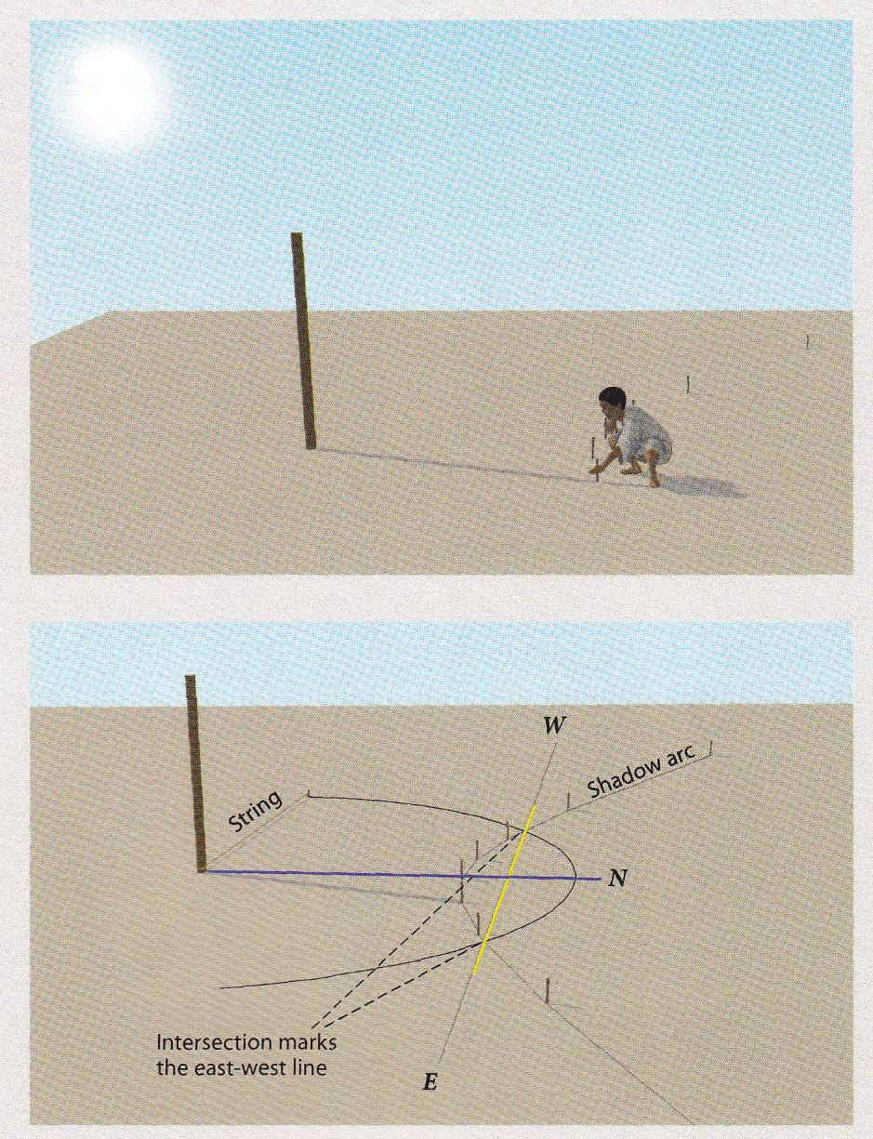

Figure 1: The Indian Circle Method. The shadow line shown here is for the winter solstice. On the summer solstice in the northern hemisphere, the shadow line bends around the gnomon instead of away from it.

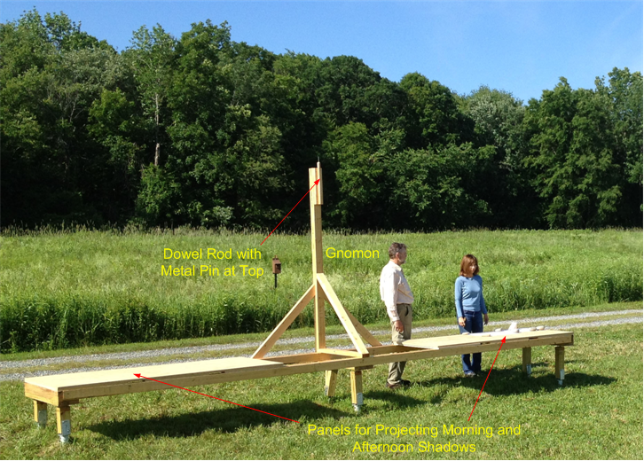

Figure 2: We tested the Indian Circle method using the apparatus shown. View is from the northwest. (Photo by Rebecca Dash)

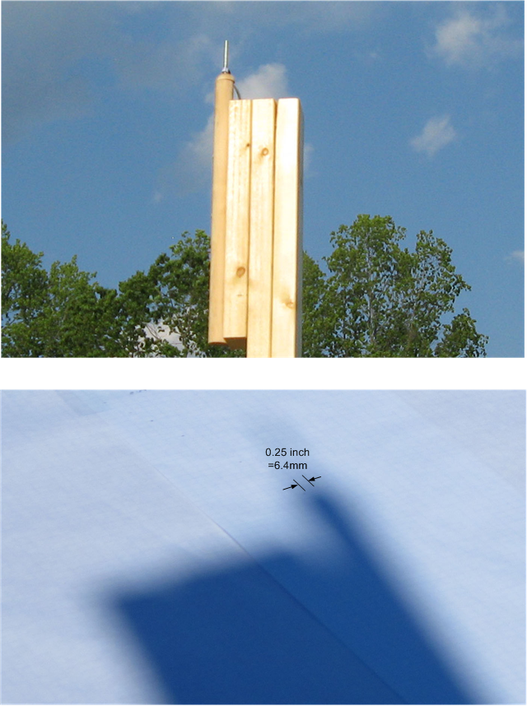

Figure 3: At top, a close up of the gnomon tip. At bottom, the gnomon’s shadow.

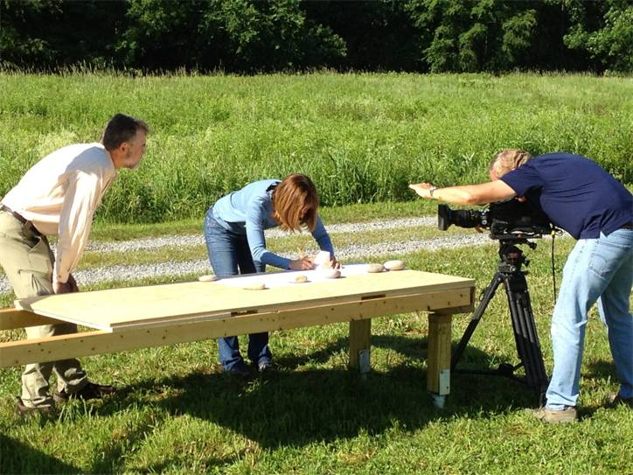

Figure 4: Indian Circle method tests in progress. The tests were filmed by a team from the series “The Universe” and used in the production “Ancient Mysteries Solved: the Pyramids.” (Photo by Rebecca Dash)

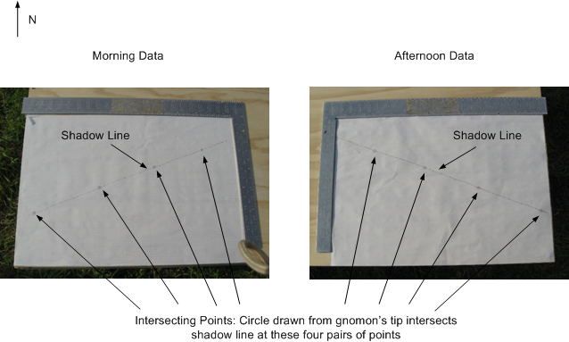

Figure 5: Typical results from the Indian Circle method test.

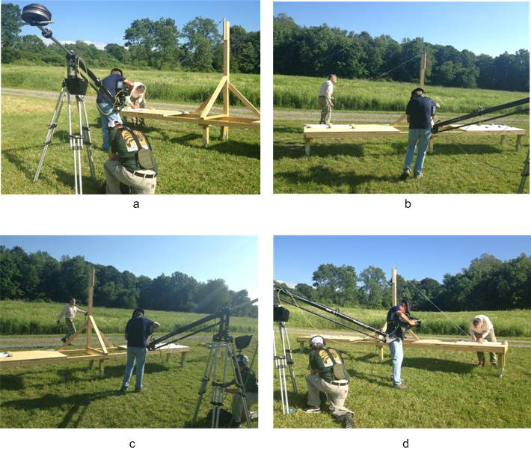

Figure 6: Drawing the circle. After the shadow line is established, a string is pulled from the top of the gnomon and matched with the shadow line on one side of the platform (a). The length of the line is then fixed and pulled over to the other side of the platform (b and c). The string is matched to the line there (d). The two points where the string and the line intersect should run straight east-west.

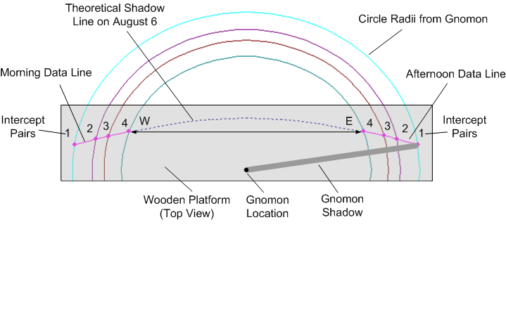
Figure 7: Top view of the platform showing the location of the shadow line, data and intercept pairs. Data taken on August 6, 2013

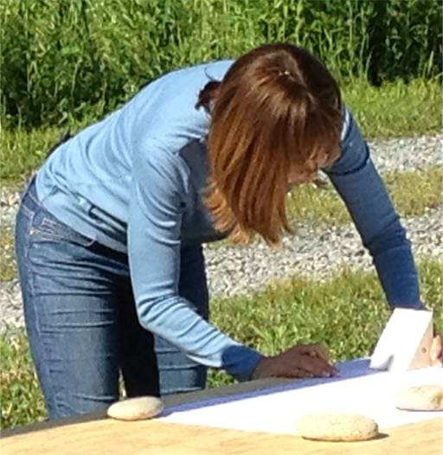

Figure 8: Joan Dash illustrates the use of an angled block as a shadow definer.

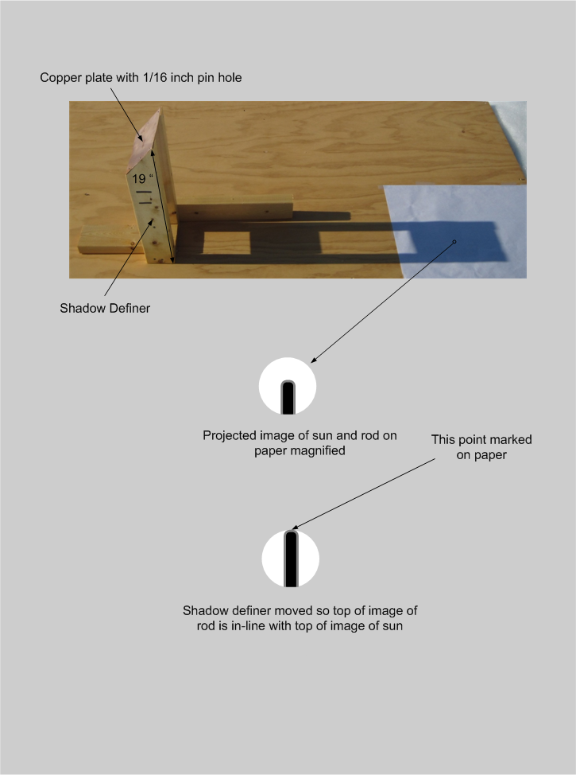
Figure 9: A pin hole punched in a copper sheet acts as a shadow definer. In my tests, the shadow definer was able to produce an image so sharp that I could see the rod projecting from the gnomon’s tip. Such a shadow definer would have allowed the Egyptians to resolve a true east-west line to with a minute or so of arc.

Revision of March 10, 2014
Lehner (1997), 212
Dash (Fall 2012), 16. There are 60 arc minutes in a degree.
Magli (2013), 90
Arnold (1991),104
Isler (1989), 197
Dash (Spring 2012, 10
Test performed on August 6, 2013
Dash (Fall 2012), 16
Test performed on June 19, 2013
Isler (1989), 197-8
Isler (1989), 198
Test performed on May 30, 2013
The Yuan Shih describes the use of the pin hole shadow definer to find the date of the solstice. It does not mention its use in finding true north.
Edwards (1993), 245
While the casing of the pyramids may have been aligned to cardinal points using the sun, the descending passageways, which face north, may have been aligned using the pole star of the time, Thuban. See Dash (2013), 8-14.

